Coding Structured Study Sessions

Setup Instructions

Ask peer tutors for help if you are stuck at any step, but you are responsible for having all the setup done **before** arriving at the first SSS, Thursday Sept 13.

## Introduction

All SSS’s will be formatted in a Jupyter (IPython) notebook which provides an interactive computational environment for running Python code. These notebooks generally contain a series of input and output cells which can contain code, text, math, plots, tables, images and more. The SSS notebooks are designed to maximize your engagement with the material thereby enhancing your Python skills and ability to think algorithmically. Thus, it’s important that you are set up to open and run these notebooks on your own machine, not only for the SSS’s, but for the assignments in FA. This document describes two options for working with Jupyter notebooks: Anaconda and CoCalc.

## Using Anaconda

We highly encourage you to try this option as it will provide a more stable experience than CoCalc. Installing this distribution on your computer means that you can run Python through your local machine rather than rely on CoCalc’s cloud based server.

1. Install Anaconda

Go to this [website](https://www.anaconda.com/download/) to download Anaconda. Just follow the instructions and accept the default settings during the process, but a few notes:

* Choose your preferred platform (Windows, macOS, Linux). Normally clicking on the link above leads to a default page that corresponds to your current platform, so you don't have to select a platform, but it's worth extra care.

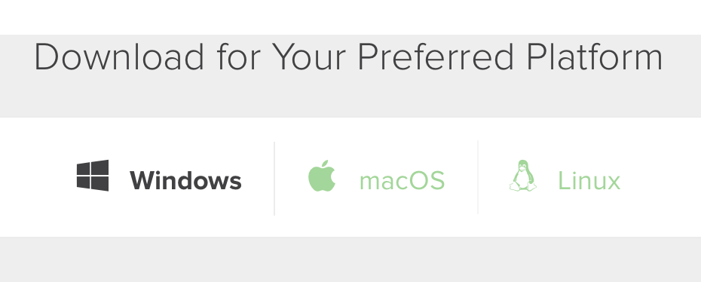

* You will have to choose between Python 3 and Python 2. Although there is not much of a difference between the two versions, please choose Python 3, as all the code in the Structured Study Sessions is run and tested on **Python 3**. We don't officially support Python 2 in SSSs.

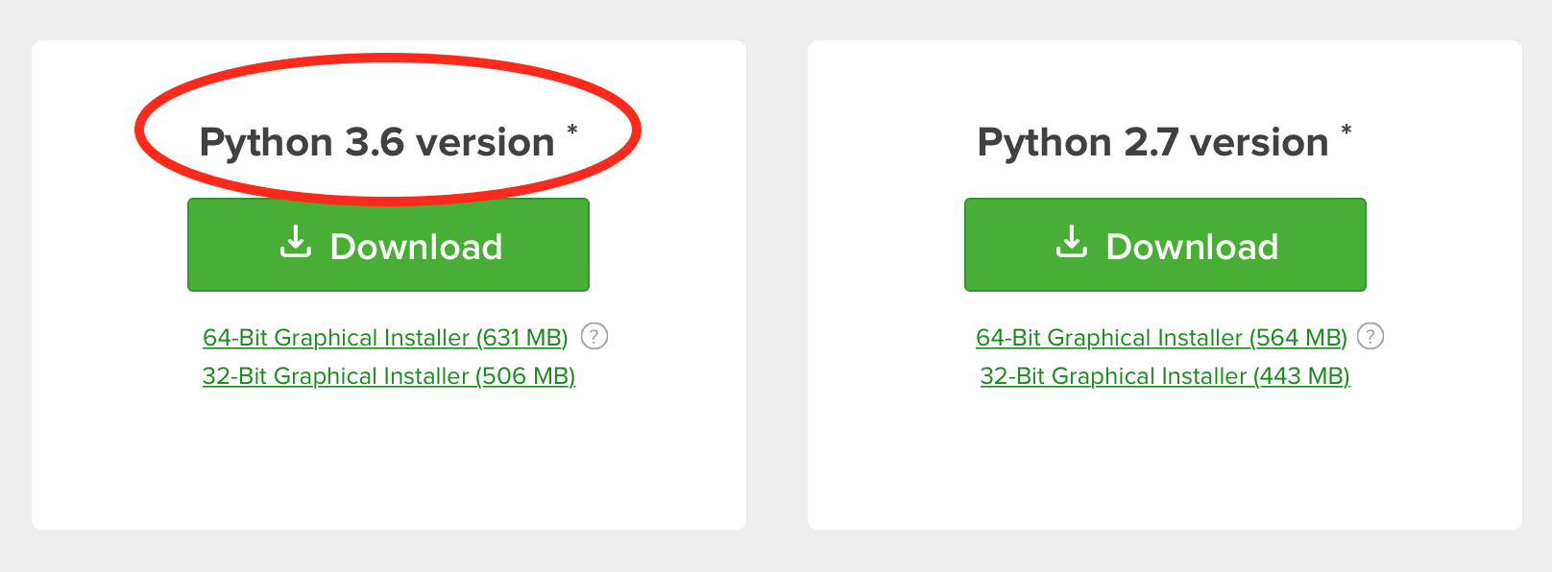

1. Download the SSS zip file

Right before every SSS we will send you the .zip file of the session via email. Download it to your computer and extract it (right click → Extract all; or simply double click on the file if you use macOS). For now, try using the .zip file [here](https://drive.google.com/open?id=1h6bokc3OkeEQxUXOrGL-cbqCQREQTAU9) as a setup test.

1. Open the IPython notebook

Open the Anaconda platform, and launch Jupyter notebook.

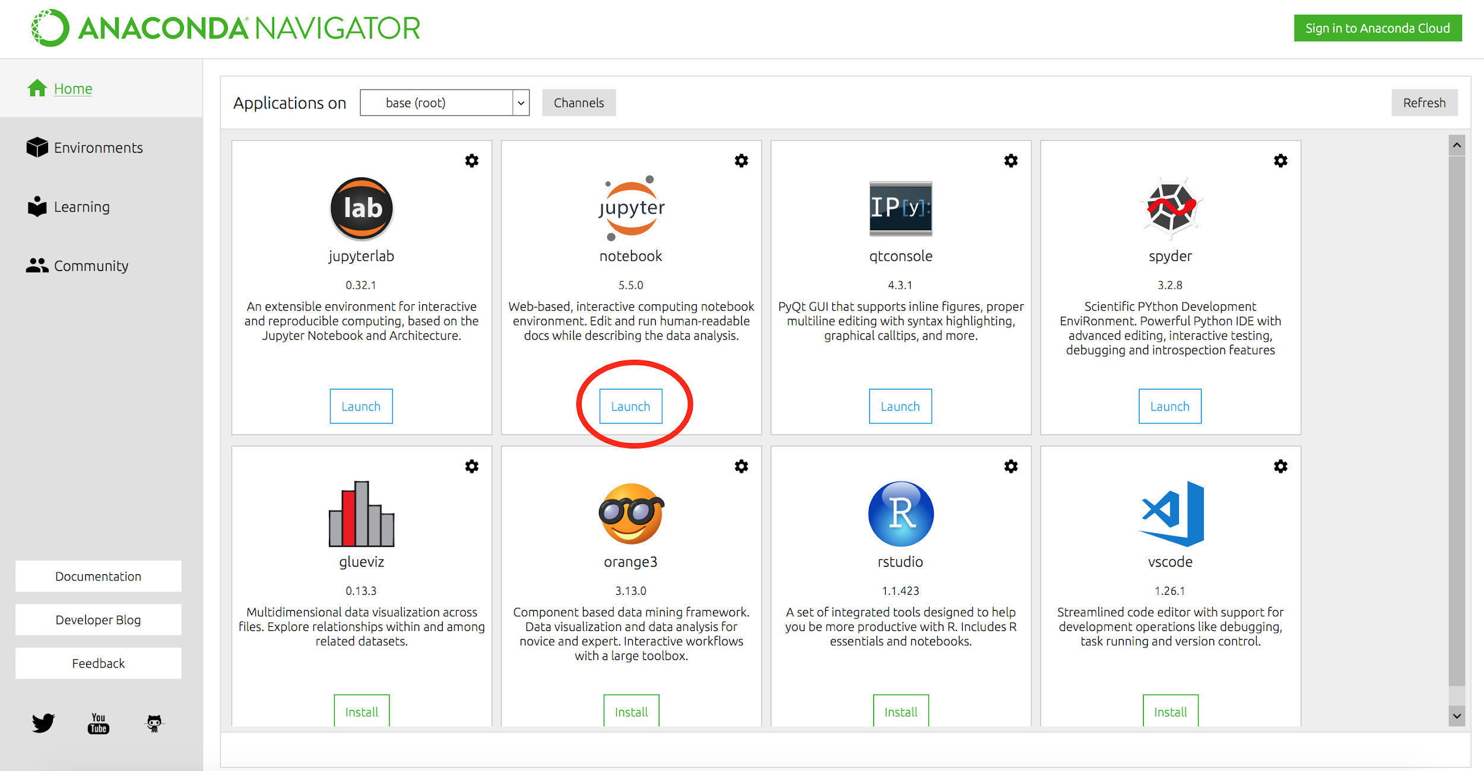

A new browser (new tab) will show up showing files and folder in your computer as in the picture below.

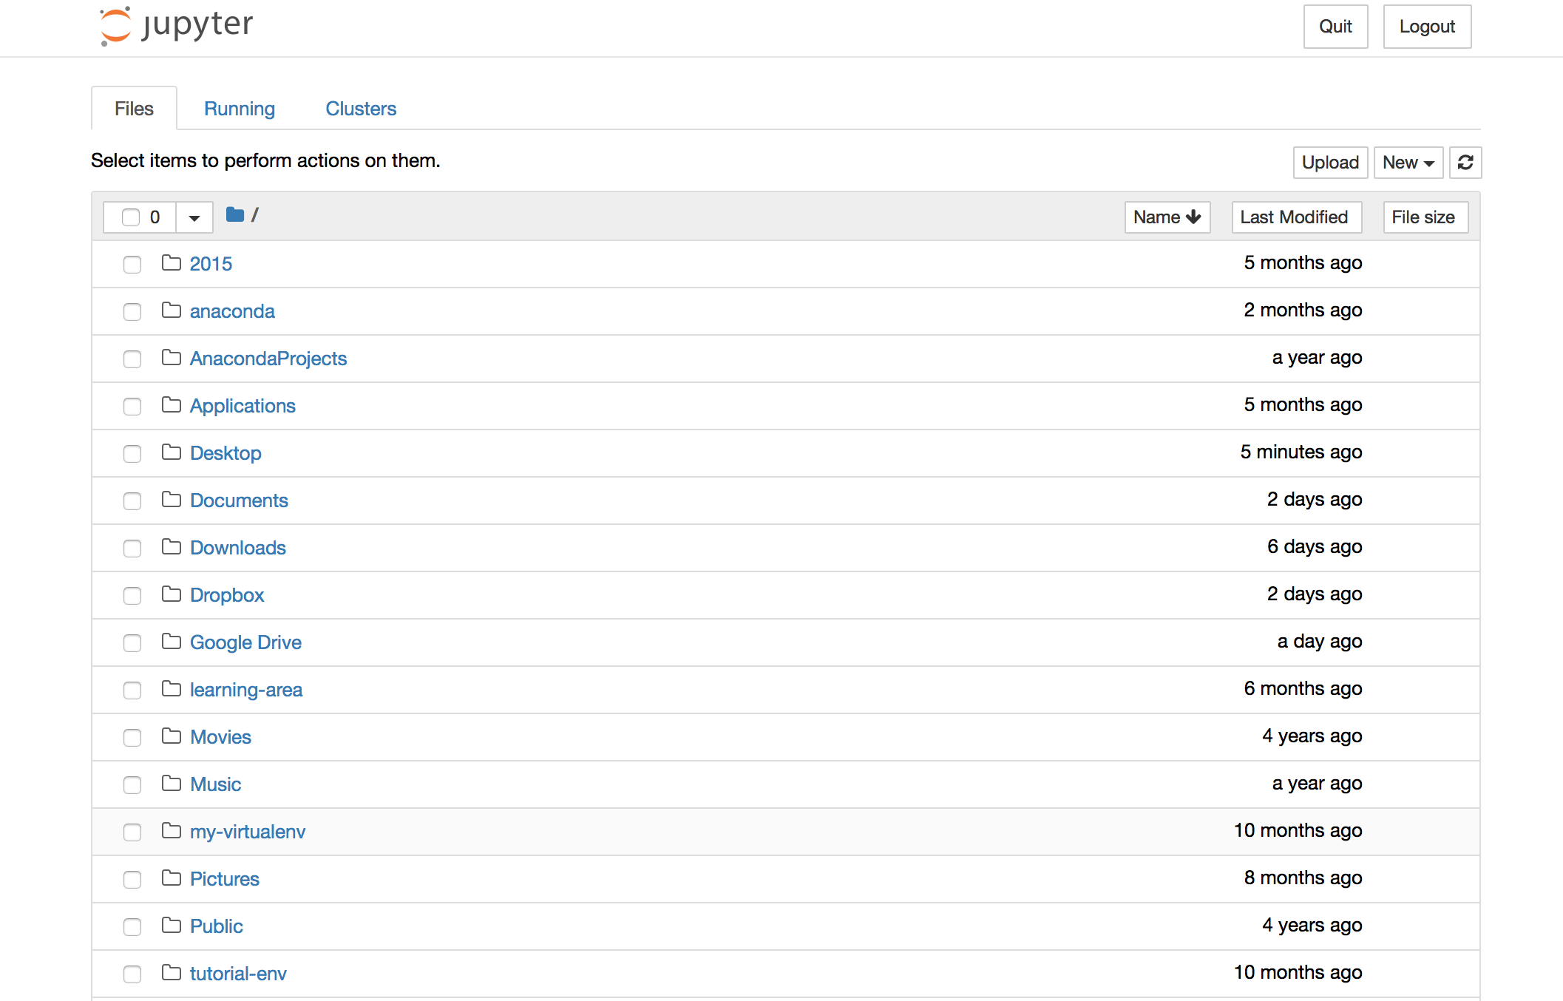

Simply navigate to where you stored the unzipped folder in step 2. You should see something similar to the display below:

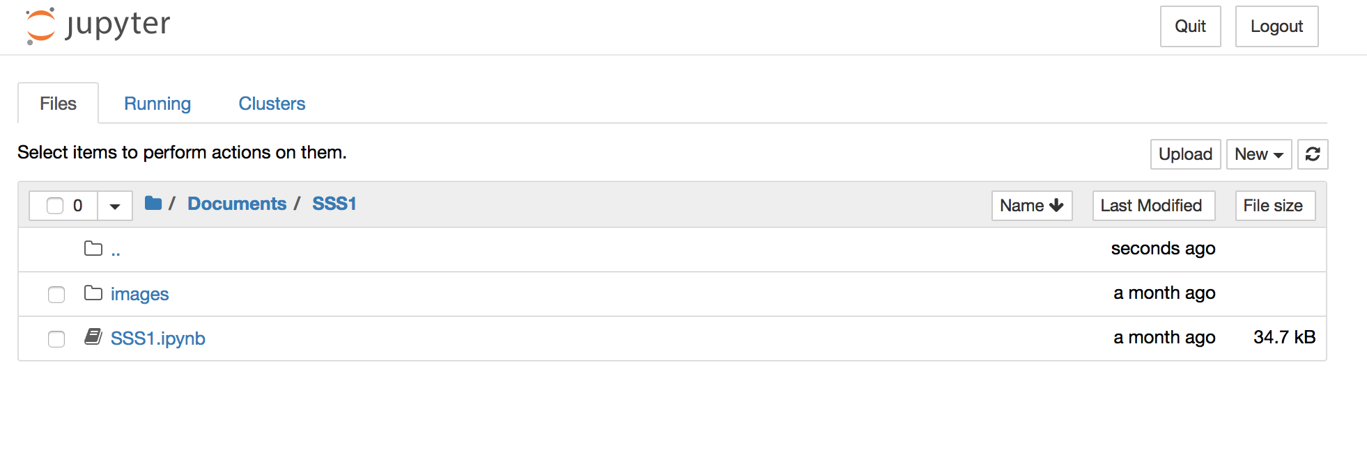

Select SSS1.ipynb (or Test.ipynb if using the test notebook). That is the file you will work with during the SSS.

## Using CoCalc

Note: Only use this method if Anaconda does not work for you (installing issues, etc.), as the Anaconda platform is more stable.

1. Download the SSS zip file: Prior to every SSS we will send you the .zip file of the session via email. Download it to your computer. (For now, try using the .zip file [here](https://drive.google.com/open?id=1h6bokc3OkeEQxUXOrGL-cbqCQREQTAU9) as a setup test.)
2. Launch CoCalc: Click on your profile picture on ALF. From the dropdown select “Launch CoCalc".
3. Create a new project by clicking on “Create New Project”

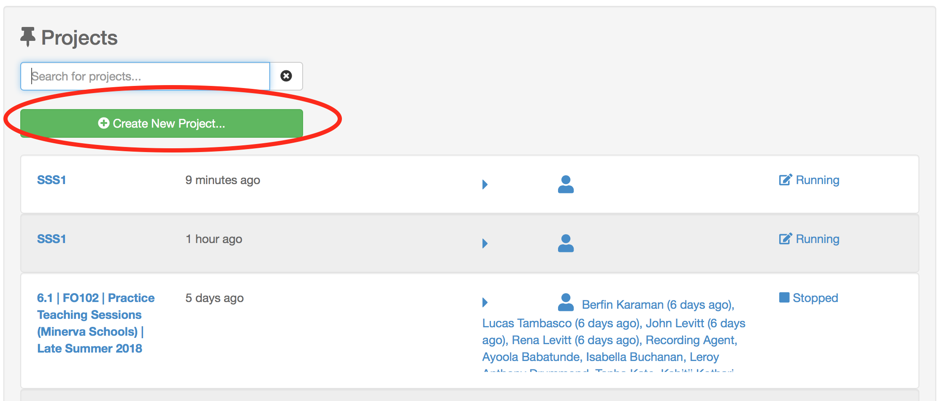

1. Click on “Create or Upload Files". Then choose the zip file you downloaded to upload.

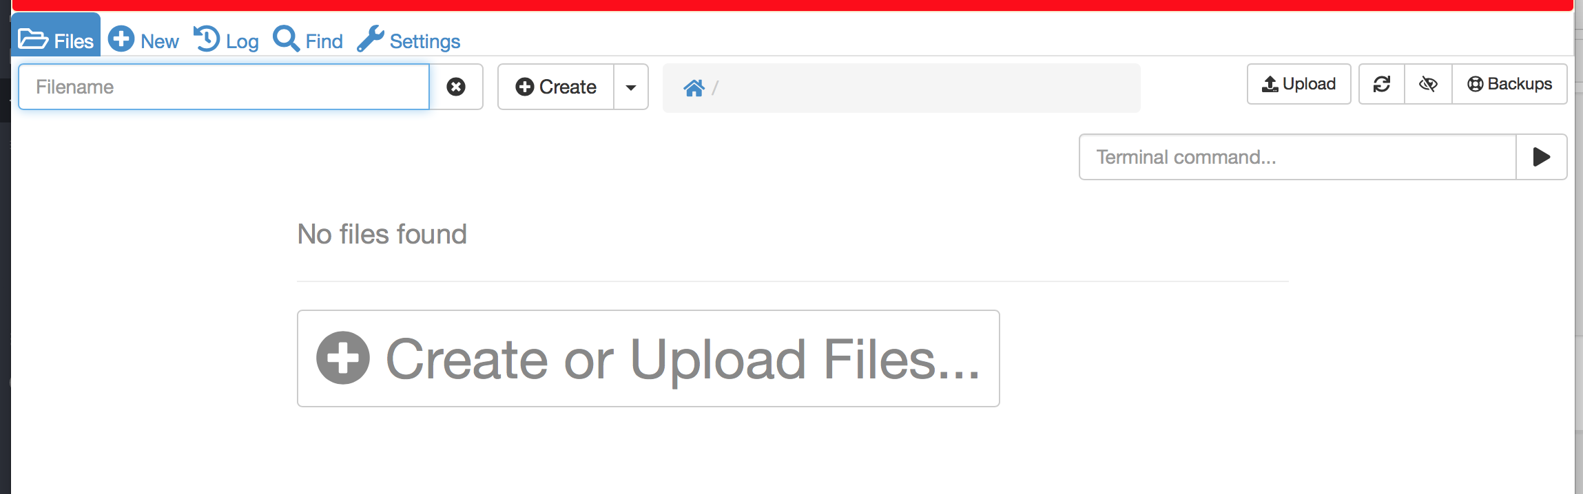

1. After uploading successfully, click on “Files" to navigate to your project home.
2. Open the .zip file and extract it.

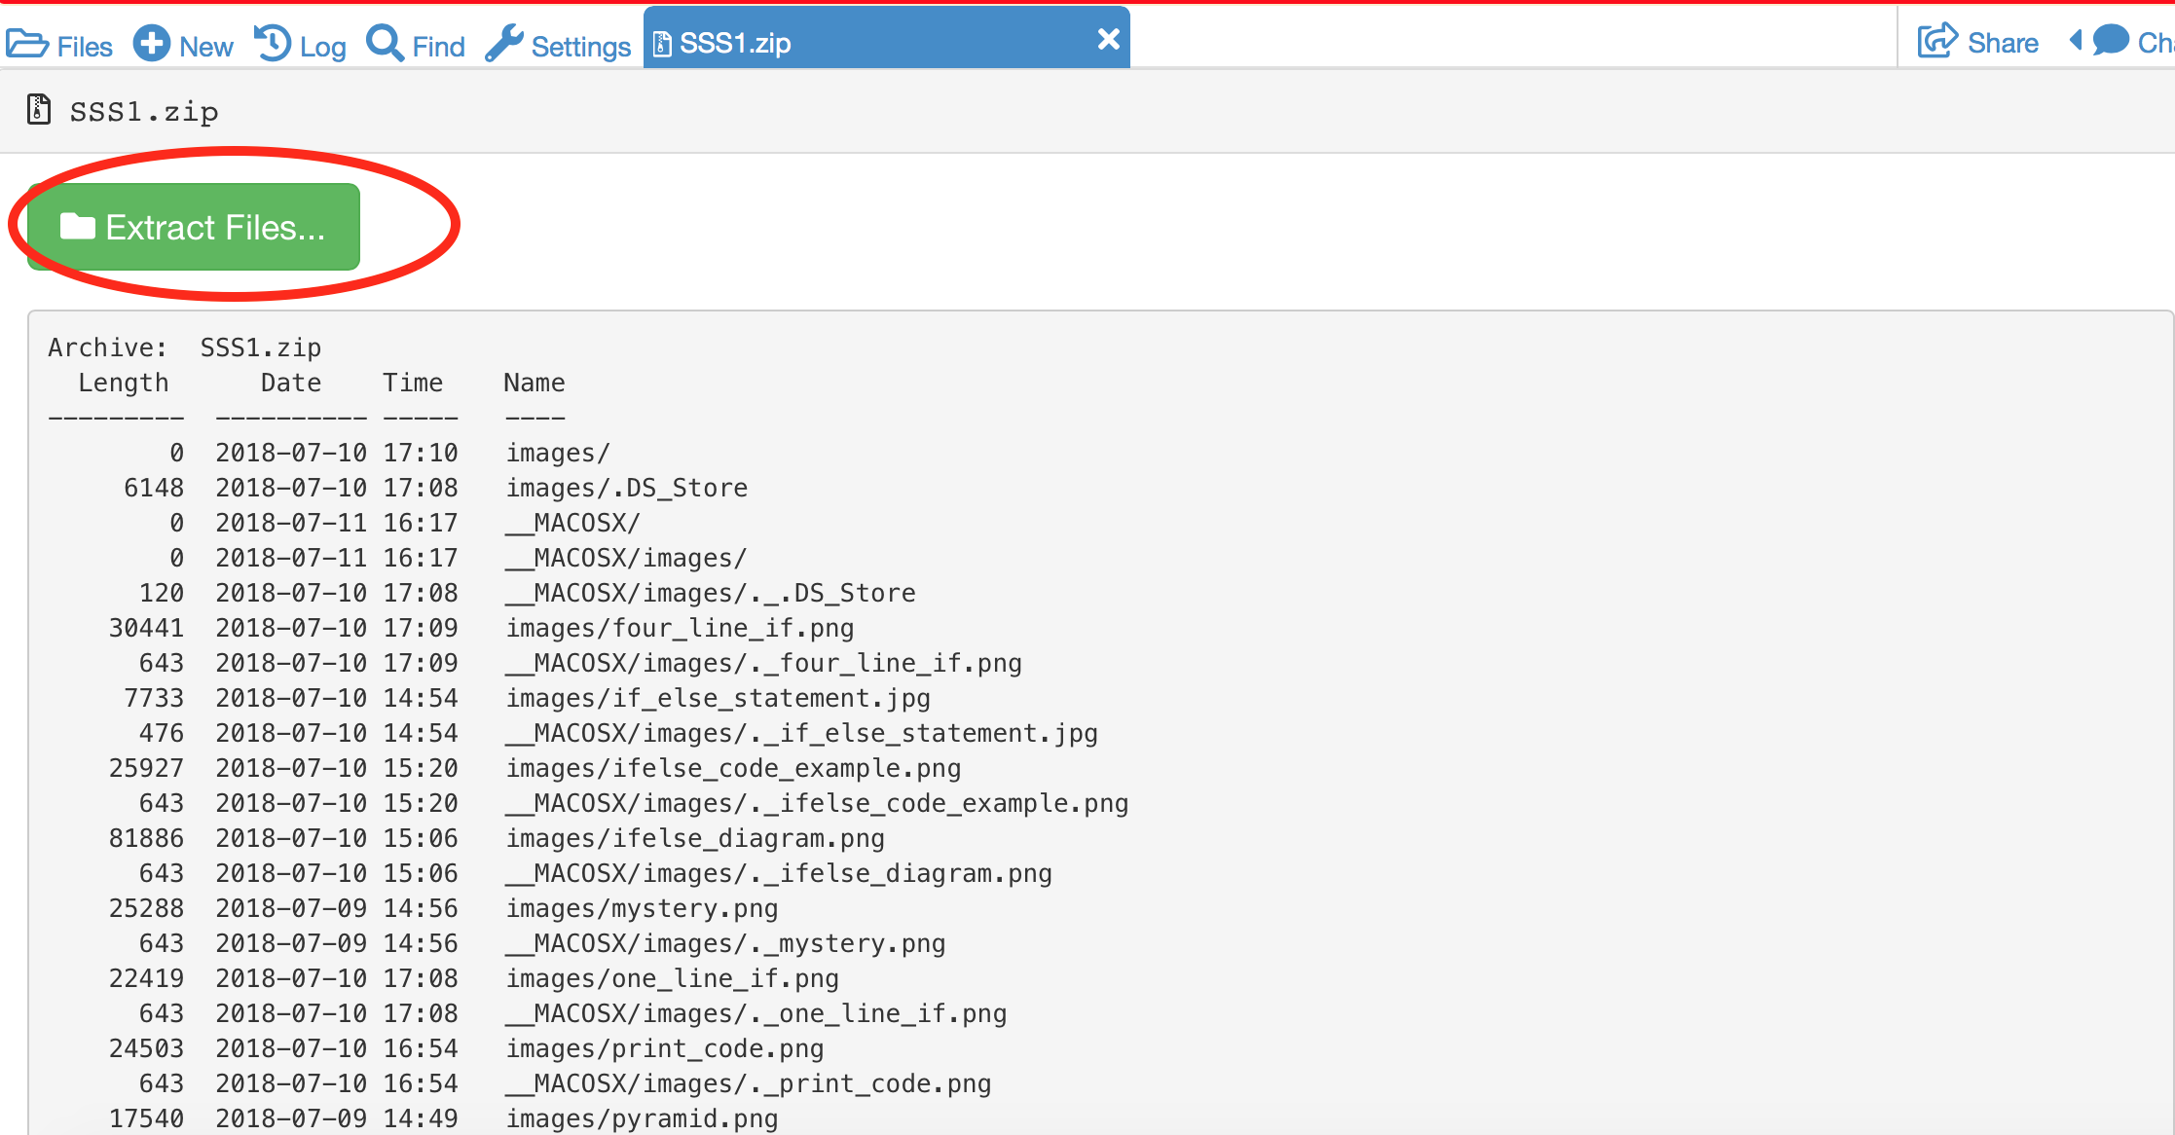

1. Click “Files”, then select SSS1 (or Test) -- the extracted folder.

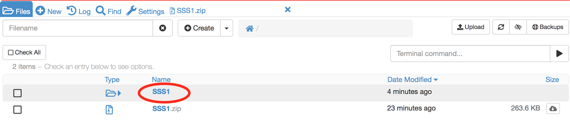

1. Select “SSS1.ipynb" (or “Test.ipynb”). That is the file you will work with during the SSS.

